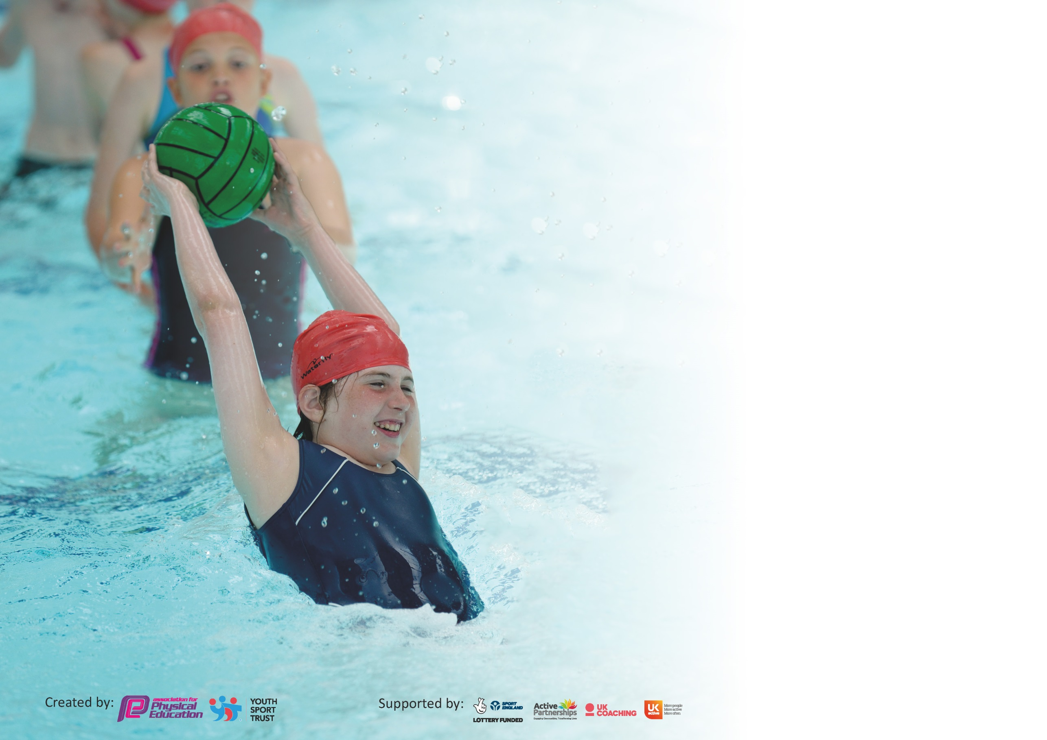

It is important that your grant is used effectively and based on school need. The Education Inspection Framework (Ofsted 2019 p64) makes clear there will be a focus on ‘whether leaders and those responsible for governors all understand their respective roles and perform these in a way that enhances the effectiveness of the school’.

Under the Quality of Education criteria (p41) inspectors consider the extent to which schools can articulate their curriculum (INTENT), construct their curriculum (IMPLEMENTATION) and demonstrate the outcomes which result (IMPACT).

To assist schools with common transferable language this template has been developed to utilise the same three headings which should make your plans easily transferable between working documents.

Schools must use the funding to make additional and sustainable improvements to the quality of Physical Education, School Sport and Physical Activity (PESSPA) they offer. This means that you should
use the Primary PE and Sport Premium to:

- Develop or add to the PESSPA activities that your school already offer
- Build capacity and capability within the school to ensure that improvements made now will benefit pupils joining the school in future years

Please visit gov.uk for the revised DfE guidance including the 5 key indicators across which schools should demonstrate an improvement. This document will help you to review your provision and to report your spend. DfE encourages schools to use this template as an effective way of meeting the reporting requirements of the Primary PE and Sport Premium.

We recommend you start by reflecting on the impact of current provision and reviewing the previous spend.

Schools are required to publish details of how they spend this funding as well as on the impact it has on pupils’ PE and sport participation and attainment by the end of the summer term or by 31st July 2020 at the latest.

We recommend regularly updating the table and publishing it on your website throughout the year. This evidences your ongoing self-evaluation of how you are using the funding to secure maximum, sustainable impact. Final copy must be posted on your website by the end of the academic year and no later than the 31st July 2020. To see an example of how to complete the table please click HERE.

Support for review and reflection - considering the 5 key indicators from DfE, what development needs are a priority for your setting and your pupils now and why? Use the space below to reflect on previous spend and key achievements and areas for development.

Key achievements to date until July 2020: | Areas for further improvement and baseline evidence of need:
Star mark achieved for Active Sports  High participation in a range of local sports festivals and tournaments  Many opportunities to take part in competitive sports  Engagement with Surrey and Surrey Heath sports associations  Variety of extra-curricular sports clubs on offer  Sensory circuits in place every day to support more vulnerable pupils  Outdoor learning  All children participate in at least 2 hours of PE each week | Outdoor mile track to be installed  Outdoor learning – to be developed further  Increased staff confidence in teaching Gymnastics

Meeting national curriculum requirements for swimming and water safety.
What percentage of your current Year 6 cohort swim competently, confidently and proficiently over a distance of at least 25 metres?  N.B. Even though your pupils may swim in another year please report on their attainment on leaving  primary school at the end of the summer term 2020. | 85%
What percentage of your current Year 6 cohort use a range of strokes effectively [for example, front crawl, backstroke and breaststroke]? | 50%
What percentage of your current Year 6 cohort perform safe self-rescue in different water-based situations? | 60%
Schools can choose to use the Primary PE and Sport Premium to provide additional provision for swimming but this must be for activity over and above the national curriculum requirements. Have you used it in this way? | No

Action Plan and Budget Tracking
Capture your intended annual spend against the 5 key indicators. Clarify the success criteria and evidence of impact that you intend to measure to evaluate for pupils today and for the future.

Academic Year: 2019/20 | Total fund allocated: £19,550 | Date Updated: 14/07/20
Key indicator 1: The engagement of all pupils in regular physical activity – Chief Medical Officer guidelines recommend that primary school pupils undertake at least 30 minutes of physical activity a day in school |  |  |  | Percentage of total allocation:
 |  |  |  | %
Intent | Implementation |  | Impact | 17%
Your school focus should be clear what you want the pupils to know and be able to do and about  what they need to learn and to  consolidate through practice: | Make sure your actions to achieve are linked to your intentions: | Funding allocated: | Evidence of impact: what do pupils now know and what can they now do? What has changed?: | Sustainability and suggested next steps:
Utilise the sports crew to offer more opportunities for sport and physical activity for children across the school. | Train staff and sports crew Monitor use of all sporting clubs and children’s involvement in fixtures/activities and target least active for engagement | External training from Active Surrey- £120 Supply - £200 | Sports crew have facilitated weekly clubs and lessons, targeting the least active and providing a range of other activities. This has also developed sports leadership skills. | Continue to train Y5 and 6 children as Sports leaders
Ensure all areas of the PE curriculum are well resourced. | Equipment purchased for the PE curriculum | £2000 | Additional basketball hoop allows for competitive games during lessons as well as providing an additional way for children to exercise during break/lunch times
daily sensory circuits to support children with sensory and emotional issues | staffing | £1000 | Sensory circuits in Hall 1 every morning help children to settle in school
Key indicator 2: The profile of PESSPA being raised across the school as a tool for whole school improvement |  |  |  | Percentage of total allocation:
 |  |  |  | %
Intent | Implementation |  | Impact | 4%
Your school focus should be clear what you want the pupils to know and be able to do and about  what they need to learn and to  consolidate through practice: | Make sure your actions to achieve are linked to your intentions: | Funding allocated: | Evidence of impact: what do pupils now know and what can they now do? What has changed?: | Sustainability and suggested next steps:
Implementation of the Active Schools school values | PE display in public areas, staff and sports crew trained to include as part of PE lessons | £300 | County finals for badminton based on display of school values by participants | Monitor PE lessons across school to ensure values are referred to regularly
Increased mindfulness and self-awareness of pupils | Headspace subscription | £500 | Pupils better knowledge of emotional self-regulation | Continue to encourage the support and use of mindfulness throughout the school
More opportunities for active breaks | Daily Mile track to be costed

Key indicator 3: Increased confidence, knowledge and skills of all staff in teaching PE and sport |  |  |  | Percentage of total allocation:
 |  |  |  | %
Intent | Implementation |  | Impact | 32%
Your school focus should be clear | Make sure your actions to | Funding | Evidence of impact: what do | Sustainability and suggested
what you want the pupils to know | achieve are linked to your | allocated: | pupils now know and what | next steps:
and be able to do and about | intentions: |  | can they now do? What has
what they need to learn and to |  |  | changed?:
consolidate through practice:
Improve students knowledge of physical health and well-being | Implementation of Jigsaw PSHE scheme across school, nursery to yr 6 | £3000 | Staff now cover physical health specifically in lessons
Provide additional training for staff, especially in gymnastics and use of climbing equipment | After-school training and demonstrations | £3000 | Ore teachers now using climbing equipment regularly as part of lessons
to achieve up-to-date PE curriculum knowledge for all members of staff | Staff attendance at Active Surrey conference | £300 | Knowledge passed onto other relevant members of staff, also implemented in active assemblies
Key indicator 4: Broader experience of a range of sports and activities offered to all pupils |  |  |  | Percentage of total allocation:
 |  |  |  | %
Intent | Implementation |  | Impact | 28%
Your school focus should be clear | Make sure your actions to | Funding | Evidence of impact: what do | Sustainability and suggested
what you want the pupils to know | achieve are linked to your | allocated: | pupils now know and what | next steps:
and be able to do and about | intentions: |  | can they now do? What has
what they need to learn and to |  |  | changed?:
consolidate through practice:
Provide pupils with a broader range of opportunities through extra-curricular clubs and through development of the PE curriculum.  Swimming badges and certificates provided as an incentive to children | Complete Coaching to provide clubs at lunchtime and after-school | £3782.93  £500 – to roll over to next year as unused | Children have more experience across a range of sports, which also gave them more confidence to try them at a competitive level | A wide range of extracurricular activities were available across the school and throughout the year. Teachers encouraged to run sport/activity-based clubs.  Reviewed every term
Pupils to be able to practise and prepare for sporting events in advance | Purchase equipment used in Sportshall Athletics Competition (reverse boards) | £100 | School team chosen to participate in Sportshall County Finals due to massively increased performance on previous year
Encouraging healthy lifestyles and habits | National Skipping Day workshop - 2 days to cover all classes | £650 | Delayed due to Covid
To allow all pupils to be able to participate in intra-school competitions | School field maintenance | £500

Key indicator 5: Increased participation in competitive sport |  |  |  | Percentage of total allocation:
 |  |  |  | %
Intent | Implementation |  | Impact | 16%
Your school focus should be clear | Make sure your actions to | Funding | Evidence of impact: what do | Sustainability and suggested
what you want the pupils to know | achieve are linked to your | allocated: | pupils now know and what | next steps:
and be able to do and about | intentions: |  | can they now do? What has
what they need to learn and to |  |  | changed?:
consolidate through practice:
Access to a wide range of sports competitions for all year groups.  A focus on getting the inactive active has meant that we are targeting more pupils through a broader range of competitions  .  Following the guidelines by Active Surrey and the Youth Sport Trust a range of competition formats are on offer to engage more pupils in inter competition. | Level 1 Intra sports events supported by school staff and sports leaders.  Level 2 Inter school sports events organised by Surrey Heath Primary School Sports Association, Active Surrey and Surrey County Sports Associations.  Level 3 Inter School County Competitions organised by Active Surrey.  Provide cover to allow staff to take pupils to wide range of events | SHSSA fees of: £140 | Higher/Aspire/Inspire events all included | Implement rota of different staff to attend events
Coach for during events to encourage and support pupils Minibus used to reach wide range of events | D Travers attends wide range of sporting events with school teams | £3000 p/a | Children feel more confident and show higher levels of skill during sporting events

Signed off by
Head Teacher:
Date:
Subject Leader: | Meg O’Duffy
Date:
Governor:
Date:

